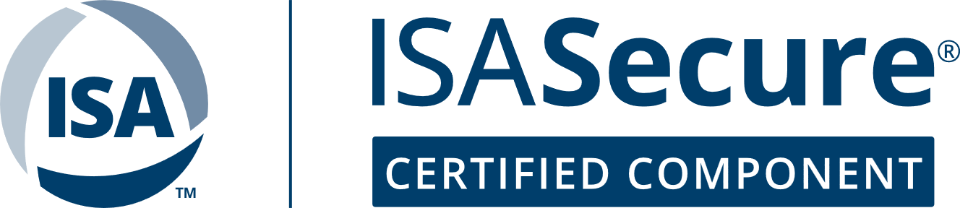

**Certificate**

SEC 08693

**Issued: March 15, 2020; Last update Sep 30, 2024**

*Certifiers,Inc.* hereby confirms that the:

**2931 Version 1.3.x Programmable Logic Controller**

**Secure Control, Inc.**

**Some City, CA**

Conforms to 62443 requirements listed, and to requirements shown in the table:

**ANSI/ISA-62443-4-1-2018, IEC 62443-4-1:2018 Secure product development lifecycle requirements**

**ANSI/ISA-62443-4-2-2018, IEC 62443-4-2:2019 Technical security requirements for IACS components**

**Meeting requirements for: Capability Security Level 2**

The normative documents and issue dates that define this certification are listed at www.isasecure.org.

Application restrictions: The unit shall be operated in a network and operational environment meeting the assumptions in the product certification report.

Product certificate remains valid under conditions:

* The following SDLA certificate remains valid: ISASecure® Security Development Lifecycle Assurance certificate number SEC 08691 issued to *Secure* *Control*, Inc.
* 2931 Version 1.3.x Programmable Logic Controller remains under the security management practices thereby certified

|  |  |  |  |  |
| --- | --- | --- | --- | --- |
| **Assessment** | **Subject under Assessment** | **Requirements** | **Date** | **Current releases at time of assessment** |
| ISASecure® CSA evaluation | 2931 Version 1.3.x Programmable Logic Controller | ISASecure Component Security Assurance 1.0.0 Capability Security Level 2 requirements for embedded devices and network devices, referencing errata CSA-102 v1.0 | March 15, 2020 | 1.3.1 |
| SDLA recertification For SEC 08691 | Development process for supplier through Aug 31, 2021 | ISASecure Security Development Lifecycle Assurance v2.0.1 | Sep 30, 2021 | 1.3.2, 1.3.3 |
| SDLA recertification  For SEC 08691 | Development process for supplier through Aug 31, 2024 | ISASecure Security Development Lifecycle Assurance v2.0.1 | Sep 30, 2024 | 1.3.5, 1.3.6, 1.3.7 |

__________________________

Authorized representative

Chartered Laboratory:

*Certifiers, Inc.*

Another City, NY, USA

License: nnnnn